Lab - ORM
40 points
This programming exercise is aimed at giving you your first experiences is developing a small Rails application. You might need to look at your book (till Chapter 8) and the example code under Lecture 3 on the blackboard to complete this. You will want to use the virtual machine installed on the lab computers for this.

Submission method:
- Submit a small description of your solution (the steps you followed to get to the solution – mention the files you edited)
- Relevant code snippets (paste here the parts you edited/added in the standard application), and screen shots.

I will only grade based on what you pasted here. If I don’t see the description and code here, I cannot grade it.

Submit a soft copy of the document using the assignment link on the blackboard.

- The following steps will guide you through adding a model with a DB backend with the course listing application completed in the previous lab. All commands are meant to be entered in the terminal. The completed version of this code is available under the Week 3 material on blackboard. It’s in your best interest not to look or copy that code till you are done with this. These are not complete instructions – they are a guide. Have the book and web access handy to figure some things out. (10 points)
  - Start a new rails application (through IDE or rails new <application_name>)
  - Generate a controller
Command: rails generate controller <controller_name> <view_name1> <view_name2> …
I suggest you use ‘main’ as the controller name and ‘list’ as one of the views.
  - Check if all is OK by starting the server and navigating to one of your views through the browser. You should see the view. Keep the server running.
Command: rails server (in a terminal window)
  - Start another terminal window. This is where we will enter the rest of the commands.
  - Generate the model. The model is linked to a Sqllite DB by default. Each model is linked to a table in the DB, you supply the attributes of the table in the generate statement.
Command: rails generate model course name:string number:string instructor:string
    - The command generates several files. Important ones: a model class – course.rb and a migration file. The migration file is located in the db\migration folder. Open the migration file and study its contents. What do you think it does?
  - Run the migration using the rake utility.
    - Learn more about the ‘rake’ utility here http://en.wikipedia.org/wiki/Rake_%28software%29 . It is the same as the ‘make’ utility, which is widely used, especially in the C/C++ world. Explain briefly what ‘rake’ does.
    - Run the db:migrate option*. Study the results in the terminal. What do you think happened?
Command: rake db:migrate
* If you get the following error, then prepend your rake command with ‘bundle exec’:
“Gem::LoadError: You have already activated rake 10.4.2, but your Gemfile requires rake 10.3.2. Prepending `bundle exec` to your command may solve this.”
Command: bundle exec rake db:migrate
This is rake version issue that you can face when upgrading.
  - Viewing the DB - The database for your application is located in db\development.sqlite3 . You will need to open the file in a SQLite viewer of your choice. Rubymine has one built-in (see on the right top corner ‘database’). You can also install an add-on called ‘SQLite Manager’ to Firefox (https://addons.mozilla.org/en-us/firefox/addon/sqlite-manager/). In either case, you will have to navigate to the db folder in your application and open the file. In Firefox (make sure you set the filter to ‘all files’).
    - Open the database and study its structure. Does anything surprise you? Unexpected attributes? Unexpected tables?
  - ‘Seeding’ the DB - Navigate to the db folder in your application. There is a file called seeds.rb. Study the description on top of the file.
    - Add the following lines to the file:
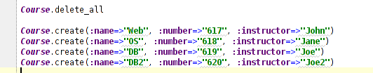

    - Run the seed task
Command: rake db:seed

    - Check the database. Any changes? What does the file do? Why would you use it?

  - Getting data from the model in the controller and sending to the view. The MVC cycle. This is very similar to the Lab you completed last time. The only difference is that the data is now pulled from the DB instead of an array. Write the following code in the controller.
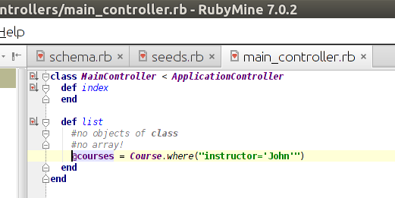

    - Notice the Course.where method. What do you think it does?

  - Write the embedded ruby code in the list.html.erb view to list the course attributes. You are on your own for this one. Nothing changes from the previous lab.

- Design and implement a small Instructor List web application. This is the almost the same as the example completed in the previous question (10 points).
  - The main page will show a listing of all Instructors in the database. The instructor details (name, office number, email) should be stored in a SQLite database. Please use the Generate Model and Migration functionality in Rails to do this. Add test data to the instructor table using the seeds.rb file. Refer to the example code completed in class (under Lecture 3).
  - Alter the instructor table to add the department name for the instructor. See Section 22.2 in book for the method to alter a table structure.
- Complete the catalog display of the Depot application. This is the Task that is completed in Chapter 8 in the book (sections 8.1-8.3). (20 points)
- You should plan to complete the code in the previous chapters – Chapter 5 and Chapter 6 before this. Skip Chapter 7 (will visit later).
- If you want to start clean, download the code till Chapter 7 by downloading depot_c from the books code repository. Download the code for depot_c from the book’s website (pick the appropriate version).

